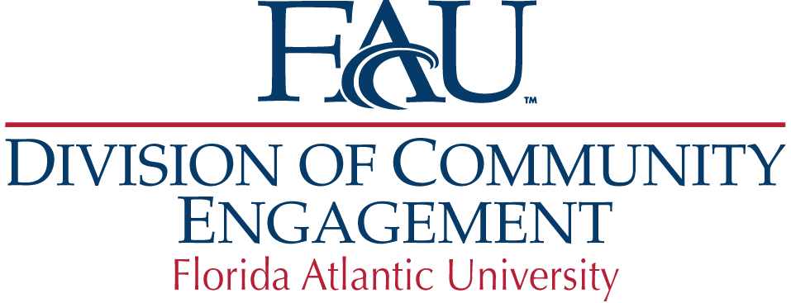

**Mission**

The mission of Florida Atlantic University’s Division of Community Engagement is to strengthen confidence in, partnerships with, and support for our university by facilitating communications and relationships with FAU’s diverse constituencies.

**Vision**

The Division of Community Engagement aspires to ensure FAU is thoroughly engaged with the communities it serves by building strong relationships with its constituencies including students, donors, alumni, businesses as well as cultural and civic organizations. We strive to strengthen FAU’s financial stability, enrich FAU’s connection to the community and play a prominent role in the economic growth of the region.

**Values**

* Integrity
* Authenticity
* Accountability
* Leading by example
* Strong work ethic
* Inspiration
* Creativity

**Strategy**

* Integrate knowledge, innovation, entrepreneurship and workforce development
* Receive, invest, and administer private gifts that support FAU and ensure expenses dually benefit the University and support University priorities
* Build a strong platform for private financial support
* Enhance and expand linkages with FAU Research Park
* Provide effective communications about the university
* Connect with and develop industry and community leaders
* Build strong partnerships and relationships through:
* Legislative outreach and advocacy
* Economic development
* Public/private partnerships
* Community service
* Alumni engagement and outreach
* Philanthropy
* Marketing and communications